A Low-Code Framework for Conversational AI Assistants Leveraging Retrieval-Augmented Generation and LLMs

¹ Thanigaivel G
Department of Computer Science and Engineering,
Vels Institute of Science Technology and Advanced Studies(VISTAS)
Chennai, India
thanigaivelrubesh1@gmail.com

² Thirumal S
Department of Computer Science and Engineering,
Vels Institute of Science Technology and Advanced Studies(VISTAS)
Chennai, India
thirumal.se@vistas.ac.in

³ Kumar N
Department of Computer Science and Engineering,
Vels Institute of Science Technology and Advanced Studies(VISTAS)
Chennai, India
kumar.se@vistas.ac.in

Abstract — With the recent advancement in the field of Artificial Intelligence in the development of the large language model which paves way for the rapid improvement of the conversational AI allowing the smart and context aware interaction between the humans and the computer in a variety of fields. These models demonstrates the ability of understanding the natural language and generates the human like response to the user queries. Many business applications has the potential to make use of these conversational AI for effective usage. But Integrating this into their applications is still difficult and requires a high level of technical expertise to incorporate these AI into their application, since it requires large amount of programming work, AI knowledge and system modification. To overcome this limitation, this paper presents a low-code framework approach of creating a domain specific conversational AI assistant with the help of LLMs and combining with the retrieval augmented generation (RAG). By using the low code platforms like Oracle APEX, the developers or the business users can easily create and integrate the smart assistants into their business applications with less technical expertise. By combining the generative AI along with the retrieval-based methods, the assistants can deliver the accurate response by referring the business knowledge sources like documents, database etc.
Keywords — retrieval augmented generation (RAG), large language model (LLM), low-code application development, Oracle APEX platform, enterprise conversational AI.
- INTRODUCTION
The rapid development of the conversational artificial intelligence significantly improves the interaction between the human and computer by enabling natural intelligent and the context-aware communication across various domains like enterprise management, customer service and education etc. With the recent development in the Large Language Models (LLM) have further improves the capabilities of the conversational agents, allowing them to understand the complex user queries and generate the human like response. Even there were of developments, but still facing some challenges in integrating the LLM powered conversational assistants into the business applications, since it requires a high level of technical expertise and AI knowledge.
The traditional conversational chatbot systems, which is typically a rule-based systems, which lacks in understanding the complex user queries and context awareness required for the dynamic business environments. These systems cannot handle complex user queries and often fails to generate accurate domain specific response. To overcome this limitation, Retrieval-Augmented Generation (RAG) has been used to improve the LLMs response by incorporating the external knowledge sources. By combining the information retrieval methods with the generative models, the conversational assistants generates business specific accurate and context aware responses.
While the RAG-based conversational AI assistants generates the accurate response, which is needed for the business applications, but facing some challenges in integrating them, since it requires high level of technical expertise. The existing methods of implementations requires lot of programming work and AI knowledge. This complexity in integration makes less usage of advanced AI capabilities into the business applications.
To overcome this limitation, this paper presents a low-code framework approach for designing the effective conversational AI assistant based on retrieval-augmented generation in combination with large language model implemented using Oracle APEX. The proposed framework combines the natural language, knowledge retrieval and response generation with simple architecture which makes it accessible to both developers and non-technical users.
- RELATED WORK
In the recent advancement in the conversational artificial intelligence in the large language models and their capability to produce human like and context-aware responses. The Traditional conversational systems was based on the rule based approach, which is limited to handle complex and domain specific queries. To overcome these limitations, the proposed paper uses the integration of the LLMs with knowledge retrieval strategies to improve both the accurate and context-aware responses.
There are numerous studies on the application of LLM-driven conversational agents in domain-specific contexts. Yin and Decker [1] demonstrates the usage of LLM-driven chatbot in academic institutions, which improves the accuracy of response to database related queries. Similarly, Sarferaz [2] has done the research on integrating the generative AI with in the business applications like enterprise resource planning (ERP) systems and highlighted the importance of context-awareness for automating the business process.
In the recent development of the Retrieval-Augmented Generation (RAG) has further improved the conversational AI by combining information retrieval with generative language models. This hybrid architecture uses the RAG which reduces the hallucination and improves the response accuracy. Yung et al. [3] proposed a RAG approach by integrating with the vector search techniques for large language document retrieval which improves the performance in real time business query handling. Additionally, recent development in the embedding based retrieval methods that have contributed to better contextual responses across divers domains.
In the meanwhile, the low-code and no-code platforms were gaining popularity for developing applications with less technical effort. Platforms such as Oracle APEX [11] and Microsoft Power Platform provides simplified development and reduces technical efforts and enables rapid development of applications. However there were limitations in integrating the advance LLM-based conversational systems with domain specific knowledge bases and often requires external services.
The Recent frameworks like LlamaIndex [12] and LangChain [13] provides the way for integrating the vector databases with LLMs, enabling efficient context aware responses. While these frameworks provides strong way for building RAG-based conversational agents they requires enormous programming expertise and requires infrastructure management which limits the technical users and low-code environments.
Based on reviewing various literature, it concludes that there is significant progress has been made in the LLM-based conversational AI and RAG architectures, however there is a gap in developing the business ready conversational assistants that can be easily configured and deployed using low-code platforms.
This work addresses there is a gap by proposing a low-code framework that integrates LLMs with Retrieval-Augmented Generation, focusses on accessibility, modularity, and seamless integration with business applications such as ERP and CRM platforms.
- PROPOSED METHODOLOGY
This paper presents a low-code framework that combines the large language models with retrieval-augmented generation (RAG) to deliver context-aware and domain-specific responses in the business applications. The framework is designed to reduce the development effort by using low-code platforms while ensuring the accuracy and seamless integration. The system’s overall process flow is depicted in the Fig. 1.

System Architecture
The proposed system architecture consists of a low-code user interface, a middleware layer, a retrieval engine, and an LLM-based response generator. The end users interact with the system through a chatbot developed using the low-code platforms such as Oracle APEX. The middleware layer handles the query preprocessing, embedding generation and retrieval generation tasks. The Knowledge sources including structed databases, ERP systems and unstructured documents are stored in the vector database to enable accurate response. The retrieved context is combined with the user queries and it is processed by the LLM to generate the accurate and domain specific responses.

User Query Handling
The user interacts with the system, by giving their inputs using a natural language query via the chatbot interface. The user interface is designed in such a way that the users can interact with the business applications without requiring the technical expertise. The user query is sent to the middleware layer, where it was preprocessed and passed to embedding and retrieval modules.

Embedding Generation
To understand the user input, the system converts the each query into a high-dimensional vector representation using the pretrained embedding models such as OpenAI Embeddings [14] or sentence- BERT. This system captures the contextual meaning and intent of the query, by allowing the system to perform matching of the business data from the knowledge sources.

Knowledge Retrieval Using RAG
The Retrieval-Augmented Generation (RAG) Modules is used to improve the LLM response accuracy by retrieving the relevant enterprise knowledge.

Document Processing
The Business knowledge sources, including ERP data, structured databases and unstructured documents are preprocessed by cleaning and segmenting them into manageable small chunks. These chunks are converted into vector embeddings using the various embedding techniques through embedding models for user query encoding and stored in the vector databases like FAISS to provide the efficient similarity based retrieval.

Query Embedding
Once the user query is received, it is transformed into a vector representation using the embedding model. A similarity search is conducted on the vector database to retrieve the most relevant documents that matches the user request.

Context Injection
The retrieved matching documents were selected based on the similarity scores by combining with the user queries. The retrieved information enhances the response generation process and improves the factual accuracy.

Augmented Prompt Construction
The retrieved information is combined with the user query to provide the relevant response. The user intent and relevant domain-specific context aware information reduces the hallucinations and generates the response that is relevant to the user queries by adhering to the business data and policies.

LLM Response Generation
The LLM model we use like GPT-4 to generate the proper, context-aware response. By using the retrieved business knowledge, the model produces the responses that are natural, factual and making them suitable for business use cases.

Integration and Deployment
The generated response is sent back to the user in the real time through the chat interface. User interactions are logged to support the continuous improvement in generating the response accurately and in the optimized way. The framework which we developed using the low-code platforms like Oracle APEX, provides the rapid integration with the existing business applications including the ERP and CRM systems. This design ensures the scalability and maintainability and accessibility for both the developers and the non-technical users.
- IMPLEMENTATION AND EVALUATION
This section covers the complete implementation methodology which proposes the approach by using the low-code conversational AI assistants which will be used efficiently in the business applications.
. This implementation is mainly focusses on reducing the development effort and integrating them seamlessly into the business applications without requiring huge technical expertise.
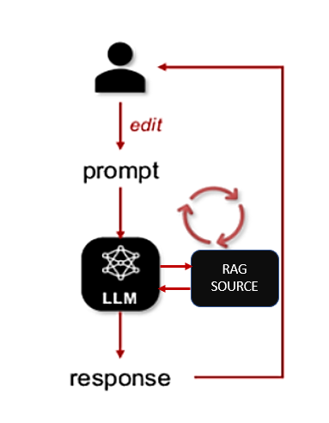
- Module Flow Diagram

Implementation Details
The proposed framework was implemented using the low-code development approach which provides the way for the rapid development and the ease of integration. The user interface was developed using the low-code platform like Oracle APEX, providing a chat-based interaction where the users will submit their queries using the natural language. The middleware layer was implemented using the RESTful APIs to handle the user query, embedding generation and communication with external AI services.
The Business knowledge sources including the structured records and unstructured documents, were converted into chunks and stored into a vector database like FAISS vector database. The vector embeddings were performed using the pretrained embedding models such as OpenAI Embeddings or sentence-BERT to store this information. The LLM models like (GPT – 4) was accessed though the API endpoints to generate the responses based on the user queries.

Experimental Setup
To evaluate the performance of the proposed framework, a set of domain-specific queries was prepared based on the business use cases, including the ERP-related questions, document based information retrieval, and general business queries. These queries were executed through the conversational chat interface and responses were generated using the RAG and LLM.
The evaluation environment consisted of:
- The frontend is developed using the low-code platform Oracle APEX.
- A vector database like FAISS for storing enterprise knowledge like embeddings.
- An LLM is used through the API for the response generation.
The proposed system was tested under the normal conditions to produce the response in relevance and contextual accuracy.

Evaluation Metrics
The proposed system architecture performance was evaluated using both the qualitative and quantitative metrics. Commonly adopted metrics in the conversational AI research:
- Response Accuracy: The degree to which the generated response, which matches the business knowledge.
- Contextual Relevance: The Ability of the system to generate the relevant response to the user query.
- Development Effort: The Development effort is reduced through the low-code integration.
- Response Latency: The Time taken to generate responses after the user query is submitted.
- Usability: The Ease of interaction for non-technical users.

Results and Discussion
Fig. 2 compares the response accuracy among different conversational AI systems. It shows that the proposed RAG-enabled conversational assistant produces more accurate and context-aware relevant response to the user query compared to the traditional rule-based chatbots
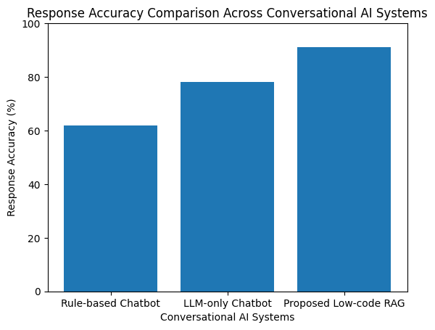
- Response Accuracy Comparison
By using the retrieval mechanisms which significantly reduces the hallucinations and ensures the generation of accurate and factual response.
Fig. 3 compares the average response latency among different conversational AI systems. Rule based chatbots produces less latency when compared to proposed low-code RAG based framework. This latency is due to the vector embedding and retrieval, however the delay remains within the acceptable limit.
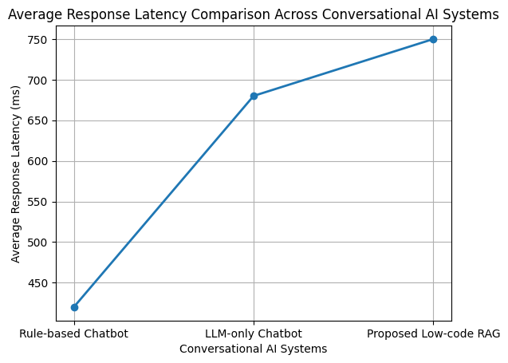
- Response Latency Comparison
Fig. 4 shows the quantitative comparison between the proposed RAG-based Chatbot with the traditional rule based and LLM chatbots. The proposed framework outperforms the traditional chatbot with highest accuracy and context aware response with less hallucination but with some increase in response latency.
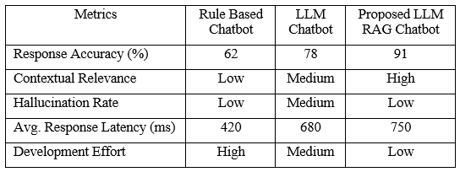
- Quantitative performance comparison across conversational AI
Overall, the results concludes that, by using the low-code platform which significantly reduces the development effort, enabling faster development and deployment. The latency involved in the response generated to the user query remains with in the acceptable limits.

Limitations
Even there were several advantages, the proposed framework has certain limitations. The response generated is strongly relied on the accuracy of the retrieved documents. Incorrect or outdated document sources will affect the response accuracy. Additionally, storing the large scale documents requires proper techniques to store and retrieve the information effectively. These document embedding consist of huge technical overhead computations.
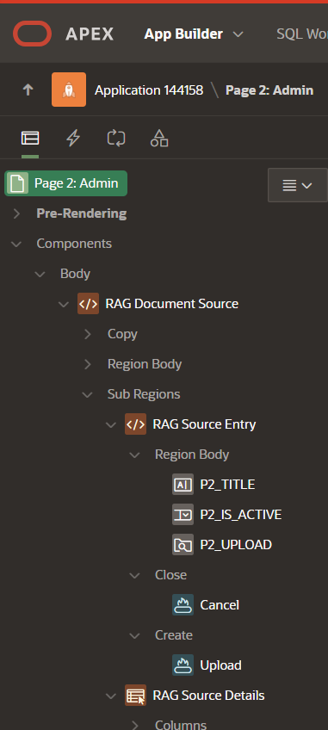
- Oracle APEX (Low-code Framework)
- Comparative Analysis and Enterprise Impact
In order to further analyze the performance of the proposed low-code RAG based conversational AI framework, by performing several comparative analysis against the traditional rule-based chatbots and LLM based conversational systems. This comparison mainly focuses on the response accuracy and contextual relevance and development efforts.
From the Fig. 4, the traditional rule-based systems shows the quick response time but failed to handle the complex user query. In contrast, the LLM based chatbots produces accurate responses but at the same time, it also produces hallucinated responses due to the lack of knowledge sources. The proposed RAG based framework achieves 91% of accuracy and provides factual and the context-aware responses with slight increase in the response latency, but it is in the acceptable limit.
From the development perspective, the traditional chatbot development requires significant coding and the effort. The Integration of low-code platform using the Oracle APEX (Fig. 5), significantly reduces the development time and provides the accurate responses, by using the knowledge data sources.
- CONCLUSION
This paper proposes a low-code framework for building the conversational AI assisstants by combining the large language modesl (LLMs) with retrieval augmented generation (RAG). This proposed approach enables accurate, context-aware and domain specifc response while significantly reducing the development effort by using the low-code platforms such as Oracle APEX. By combining the large language models with retrieval augment generation methods, this framework provides the accurate and reliable responses using the business knowledge sources.
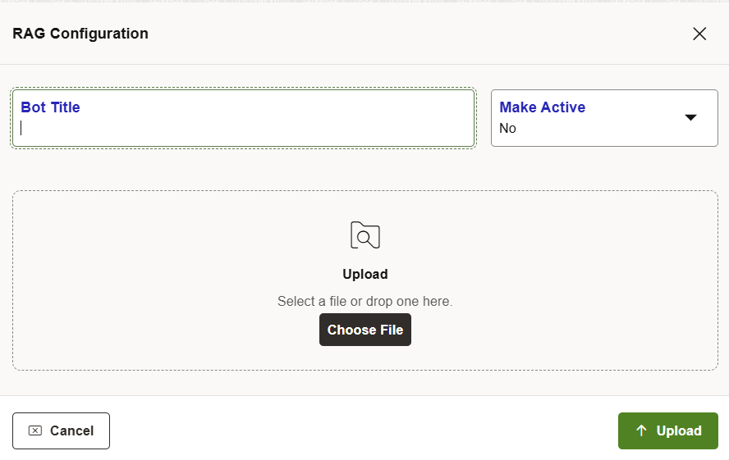
- RAG Configuratin Admin Page
Furthermore, the proposed framework highlights, how the low-code platforms will help in developing the conversational AI in the enterprise environments. By reducing the complexity, the system allows the organizations to focus on the business requirements rather than focusing on the technical implementation challenges.
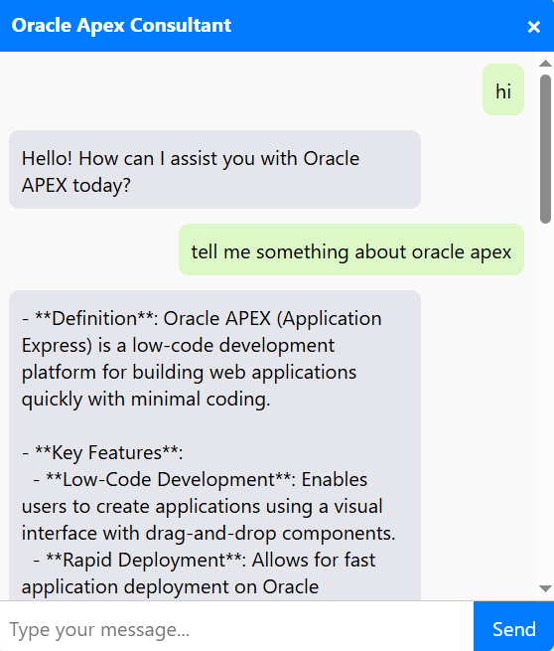
- RAG Powered Chatbot
- FUTURE WORK
Future enhancements to the proposed framework will include in the integration of multimodal interaction capabilities such as voice-based input and real time language translation that enable more natural communication. The framework can also extended into multi-agent architechture which is capable of handling complex business task such as scheduling, reporting and automate the business process.
Furthermore, incorporating continuous learning mechanisms based on the user feedback and queries, the cloud-native deployment strategies can improve the scalability, adaptability and the performance, domain-specific optimizations for sectors such as healthcare, finance and supply chain management also present the promising directions in extending the usage of the proposed framework.
- REFERENCES
[1] Y. Yin and S. Decker, “LLM-based chatbot applications in higher education for databases and information systems,” Proc.IEEE Conf. on Artificial Intelligence in Education, 2025.
[2] S. Sarferaz, “Implementing generative AI into ERP software,” Proc. IEEE Int. Conf. on Enterprise Systems, 2025.
[3] R. Yang et al., “Engineering retrieval augmented generation based virtual assistants in practice,” Technical report, 2025.
[4] C. Jeong, “Beyond text: Implementing multimodal LLM-powered multi-agent systems using a no-code platform,” Proc. IEEE Int. Conf. on Artificial Intelligence, 2025.
[5] S. Ghosh and G. Mittal, “Low-code RAG & LLM framework for the context aware querying in the electrical standards, design and research ” Technical report, 2025.
[6] O. Marquez Ayala and P. Béchard, “Generating a low-code workflow via task decomposition and retrieval-augmented generation,” Proc. IEEE Int. Conf. on Software Engineering Workshops, 2024.
[7] Y. Cai, Z. Xing, et al., “White-box LLM-supported low-code engineering: A vision and first insights,” Proc. ACM/IEEE MODELS Companion, 2024.
[8] IEEE Software Editorial Board, “The next frontier in software development: AI-augmented software development processes,” IEEE Software, volume. 40 , No. 3, PP. 5 - 8, 2023.
[9] J. Terven, A.Arguelles, and I.Cervantes, “Intelligent driving assistance system using retrieval-augmented generation,” Proc.IEEE International. Conference on Intelligent Transportation Systems, 2024.
[10] S. Aboukadri and I. El Asri, “Leveraging retrieval-augmented generation and large language models for access control policy extraction from user stories in agile software development,” Proc. IEEE Int. Conf. on Software Engineering, 2025.
[11] Oracle, “The Oracle APEX document,” [Online]. Available: https://docs.oracle.com/en/database/oracle/apex/
[12] LlamaIndex, “LlamaIndex document,” [Online]. Available: https://llamaindex.ai
[13] Lang-Chain, “The Lang-Chain document,” [Online]. Available: https://docs.langchain.com
[14] OpenAI, “Embeddings API document,” [Online]. Available:
https://platform.open ai.com/docs/guides/embeddings
[15] B.Tural, Z.Örpek, and Z.Destan, “Retrieval augmented generation (RAG) & LLM integration,” in 2024 8th International Symposiym. on Innovative Approaches in Smart Technologies (ISAS), IEEE , 2024.
[16] B. Shelley, P. Kaur, G. Aggarwal, A. Kaushal, and M. K. Dutta, “Flora-RAG: Enhancing conversational AI with retrieval augmented generation for floriculture,” in 2025 Int. Conf. on Engineering, Technology & Management (ICETM), IEEE, 2025.
[17] B.Sawarkar, A.Mangal, and S.R.Solanki, “Blended RAG : Improving retrieval augmented generation accuracy, with semantic search and hybrid query based retrievers,” in the 2024 IEEE 7th Int. Conf. on the Multimedia Information Processing & Retrieval (MIPR ), IEEE, 2024.

